

**Narrogin Senior High School**

**Semester One Examination, 2019**

**ATAR MODERN HISTORY**

**Year 11 Unit 1**

**Document set 1**

**SOURCE BOOKLET**

**Document Set 1: Capitalism – the American Experience 1907–1941**

**Source 1**

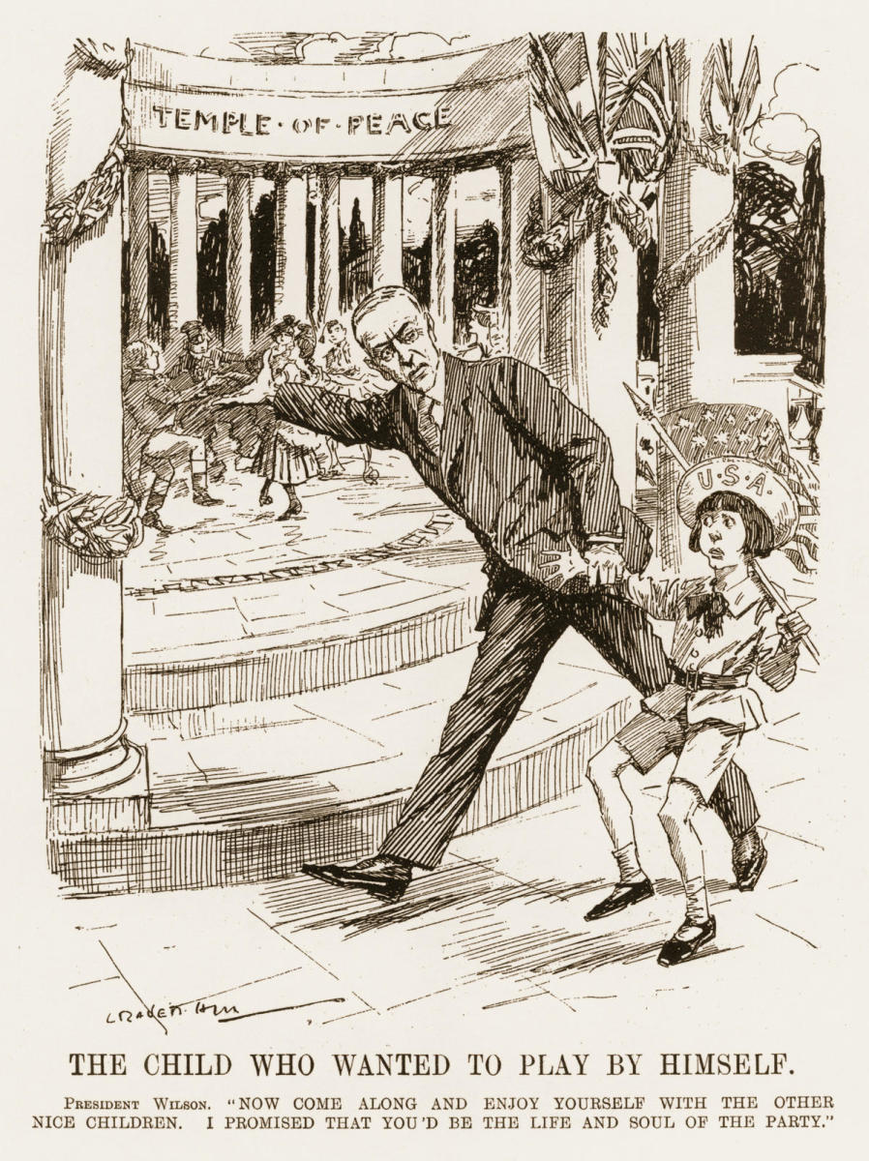

**‘The Child Who Wanted to Play by Himself’**

1919 editorial cartoon depicting US President Woodrow Wilson as he pulls a reluctant young boy towards the League of Nations

**Source 2**

“He [President Wilson] was opposed by a powerful group of senators led by Henry Cabot Lodge. Liberal historians have been largely successful in representing them as ignorant, backward isolationists. In reality they were prudent realists and traditional nationalists who did not share Wilson’s faith in world public opinion, were unprepared to sign a blank cheque for collective security, and believed that the United States should not undertake commitments that it might not be prepared to honour when push comes to shove. They believed that the United States should promote democracy by its example, not by its power.”

Owen Harries, *Understanding America* (2002), The Centre for Independent Studies, pp. 22-23.

**Source 3**

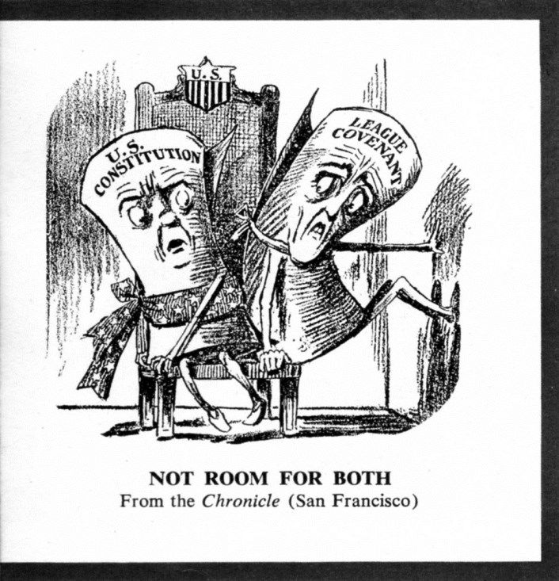

‘Not Room for Both’, circa 1919

A cartoon from the San Francisco Chronicle who supported American isolationist policies.

**Source 4**

“Unless you get the united, concerted purpose and power of the great Governments of the world behind this settlement, it will fall down like a house of cards. There is only one power to put behind the liberation of mankind, and that is the power of mankind. It is the power of the united moral forces of the world, and in the Covenant of the League of Nations the moral forces of the world are mobilized.”

An excerpt of a speech by Woodrow Wilson, 25th September 1919.



**Narrogin Senior High School**

**Semester One Examination, 2019**

**ATAR MODERN HISTORY**

**Year 11 Unit 1**

**Document set 2**

**SOURCE BOOKLET**

**Document Set 2: Capitalism – the American Experience 1907–1941**

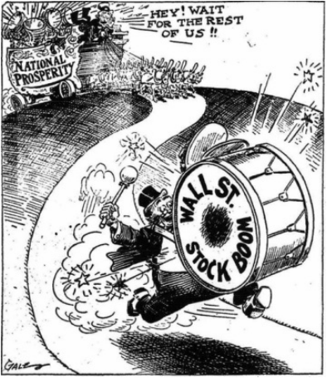**Source 1**

**"Getting Ahead of the Band Wagon!"**

Los Angeles Times, 1928

**Source 2**

**The Wall Street Crash**

“The economy ceased to expand in June 1929. The bull market in stocks really came to an end on September 3. The later ‘rises’ were merely hiccups in a steady downward trend. . . . In the confusion the panic intensified . . . and speculators began to realize they might lose their savings and even their homes. On Thursday, October 24 shares dropped vertically with no one buying, speculators were sold out as they failed to respond to margin calls, crowds gathered in Broad Street outside the New York Stock Exchange, and by the end of the day eleven men well known in Wall Street had committed suicide. Next week came Black Tuesday, the 29th, and the first selling of sound stocks in order to provide desperately needed (funds). . . . . By July 8, 1932 the *New York Times* industrials had fallen from 224 at the end of the panic to 58. US Steel, selling at 262 before the market broke in 1929, was now only 22. GM, on of the best-run and most successful manufacturing groups in the world, had fallen from 73 to 8.”

Paul Johnson, “A History of the American People” (Weidenfeld & Nicolson, London, 1997), pp 613-614

**Source 3**

**The First 100 Days**

March 4, 1933, was perhaps the Great Depression's darkest hour. The stock market had plunged 85% from its high in 1929, and nearly one-fourth of the workforce was unemployed. In the cities, jobless men were lining up for soup and bread. In rural areas, farmers whose land was being foreclosed were talking openly of revolution. The crowd that gathered in front of the Capitol that day to watch Franklin D. Roosevelt's Inauguration had all but given up on America. They were, a reporter observed, "as silent as a group of mourners around a grave."

Roosevelt's Inaugural Address . . . won rave reviews. Even the rock-ribbed Republican Chicago *Tribune* lauded its "dominant note of courageous confidence." F.D.R. had buoyed the spirits of the American people — and nearly 500,000 of them wrote to him at the White House in the following week to tell him so.

Hours after the Inauguration, Roosevelt made history in a more behind-the-scenes way. He gathered his Cabinet in his White House office and had Justice Benjamin Cardozo swear them in as a group, the first time that had ever been done. F.D.R. joked that he was doing it so they could "receive an extra day's pay," but the real reason was that he wanted his team to get to work immediately.

By American historian Adam Cohen

Source: http://content.time.com/time/specials/packages/article/0,28804,1906802_1906838_1906979,00.html

(Retrieved: 22/12/2018)

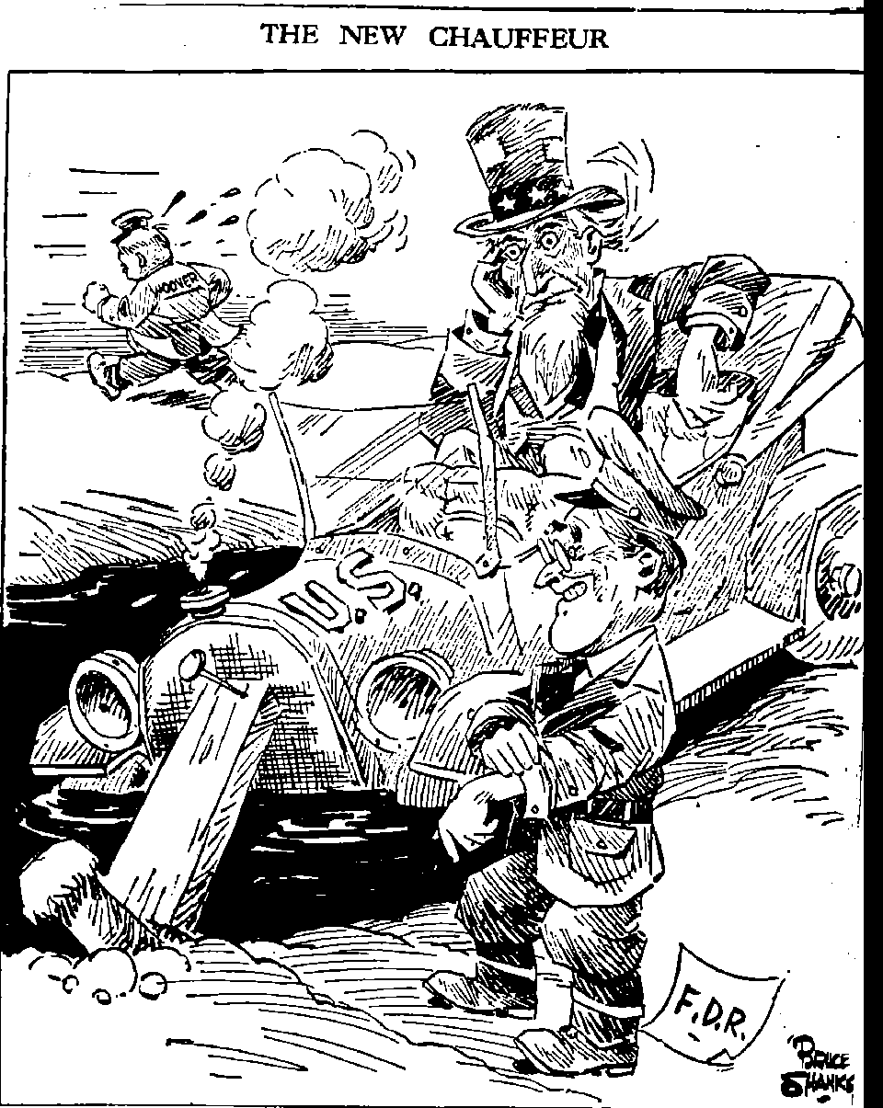**Source 4**

**The New Chauffeur**

**by American cartoonist, Bruce Shanks**

**January 3, 1933**

The new chauffeur is Roosevelt, the old one running away is Herbert Hoover